Kubernetes Task 5

- Create a namespace dev-environment and apply a resource-based quota that restricts the number of pods to 3 and services to 2.
- Create a pod in the prod-environment namespace with 0.2 CPU and 200Mi memory requests, and 0.5 CPU and 500Mi memory limits.
- In the staging-environment namespace, set a LimitRange that assigns default CPU and memory limits (300m CPU, 600Mi memory) and applies a minimum and maximum CPU.
- Create a pod and a NodePort service in the default namespace, then create another pod in the test namespace and communicate between them using Service DNS.
- Apply a LimitRange with a max limit/request ratio of 2 for memory in the performance-environment namespace, and test by creating a pod with mismatched resource requests and limits.

Step 1: ResourceQuota
We'll create:
dev-environment
│
└── ResourceQuota
├── Pods: 3 maximum
└── Services: 2 maximum
1. Create namespace
Run:
kubectl create namespace dev-environment
2. Create the quota YAML
Run:
nano dev-quota.yaml
Paste this exactly:
apiVersion: v1
kind: ResourceQuota
metadata:
name: dev-resource-quota
namespace: dev-environment
spec:
hard:
pods: "3"
services: "2"
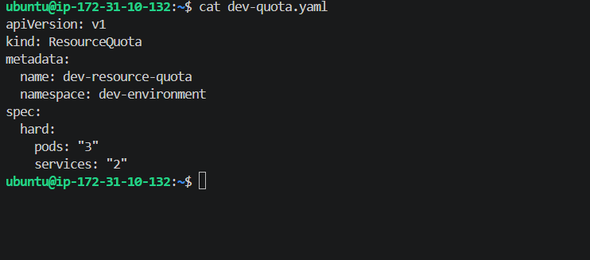
3. Apply it
kubectl apply -f dev-quota.yaml
4. Verify
kubectl get resourcequota -n dev-environment
Then:
kubectl describe resourcequota dev-resource-quota -n dev-environment
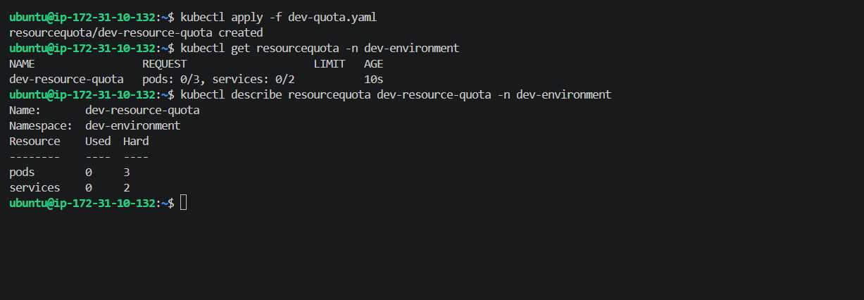

Step 2: Pod Resource Requests & Limits
Now we'll create the prod-environment namespace and a Pod with the exact resource requirements.
Requirement
Resource | Request | Limit
CPU | 200m | 500m
Memory | 200Mi | 500Mi
1. Create namespace
Run:
kubectl create namespace prod-environment
Expected:
namespace/prod-environment created
2. Create the Pod YAML
Run:
nano prod-pod.yaml
Paste:
apiVersion: v1
kind: Pod
metadata:
name: prod-pod
namespace: prod-environment
spec:
containers:
- name: nginx
image: nginx:latest
resources:
requests:
cpu: "200m"
memory: "200Mi"
limits:
cpu: "500m"
memory: "500Mi"
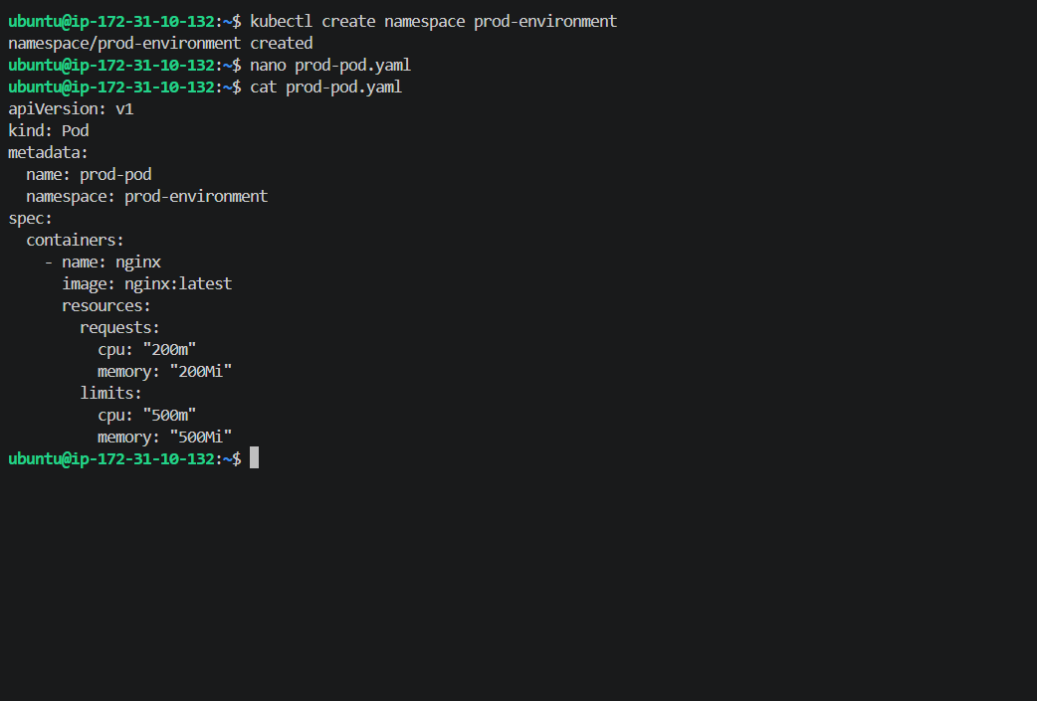
3. Apply
kubectl apply -f prod-pod.yaml
4. Check Pod
kubectl get pods -n prod-environment
You should see:
NAME READY STATUS RESTARTS AGE
prod-pod 1/1 Running 0 ...
5. Verify the resources
Run:
kubectl describe pod prod-pod -n prod-environment
Look for:
Requests:
cpu: 200m
memory: 200Mi

Limits:
cpu: 500m
memory: 500Mi
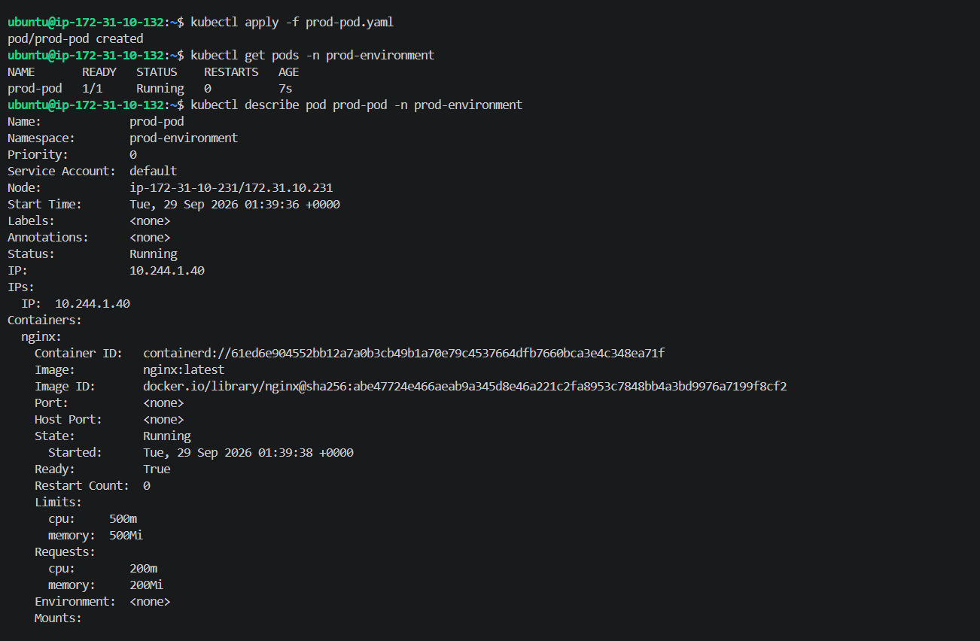
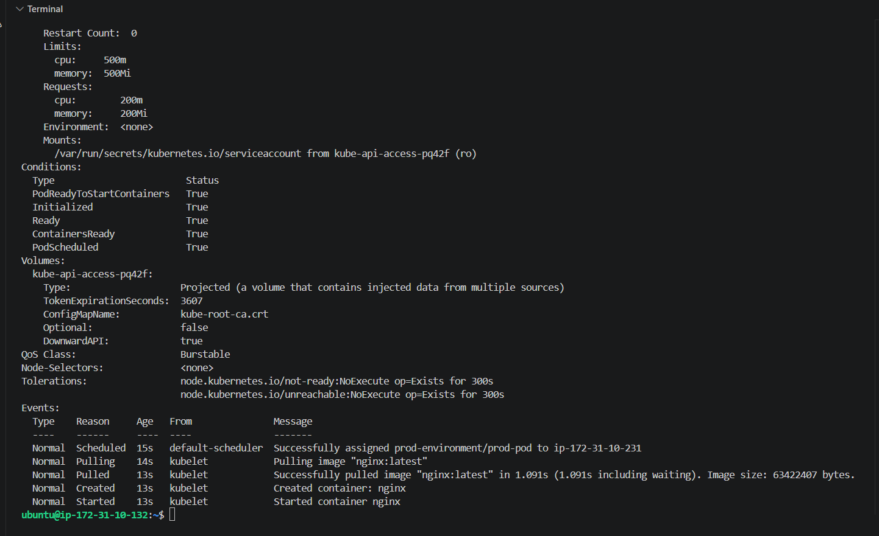
You can also verify directly with:
kubectl get pod prod-pod -n prod-environment \
-o jsonpath='{.spec.containers[0].resources}'
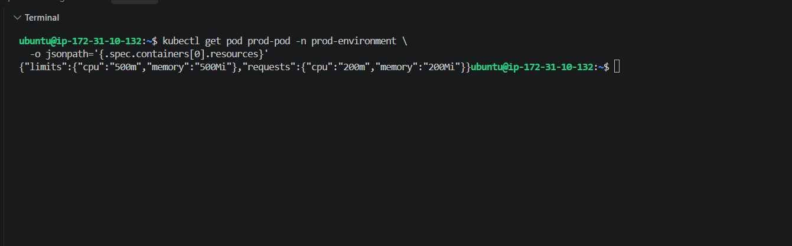
Step 3 — Staging LimitRange
Now we'll create:
staging-environment
│
└── LimitRange
├── Default CPU: 300m
├── Default Memory: 600Mi
├── Minimum CPU: 100m
└── Maximum CPU: 800m
1. Create namespace
kubectl create namespace staging-environment
2. Create LimitRange
nano staging-limitrange.yaml
Paste:
apiVersion: v1
kind: LimitRange
metadata:
name: staging-limitrange
namespace: staging-environment
spec:
limits:
- type: Container
min:
cpu: "100m"
max:
cpu: "800m"
default:
cpu: "300m"
memory: "600Mi"
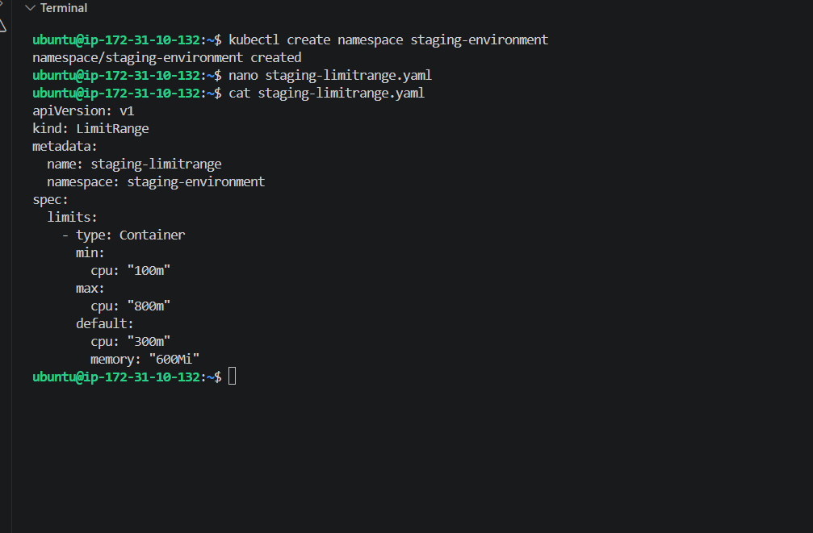
3. Apply
kubectl apply -f staging-limitrange.yaml
Expected:
limitrange/staging-limitrange created
4. Verify
kubectl get limitrange -n staging-environment
Then:
kubectl describe limitrange staging-limitrange -n staging-environment
You should see:
Type Resource Min Max Default
---- -------- --- --- -------
Container cpu 100m 800m 300m
Container memory 600Mi
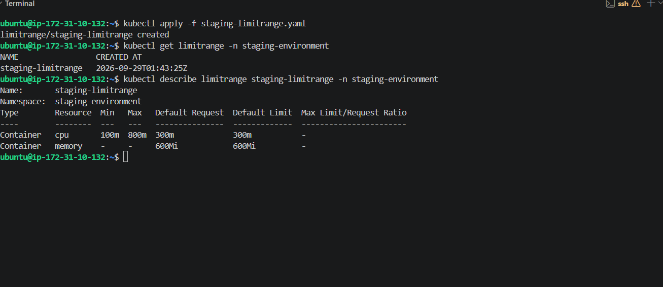
5. Test the default values
This is important because it proves the LimitRange actually works.
Create a Pod without specifying any CPU or memory:
kubectl run staging-pod \
--image=nginx \
-n staging-environment
Then:
kubectl get pod staging-pod -n staging-environment \
-o jsonpath='{.spec.containers[0].resources}'
We expect Kubernetes to automatically add:
limits:
cpu: 300m
memory: 600Mi
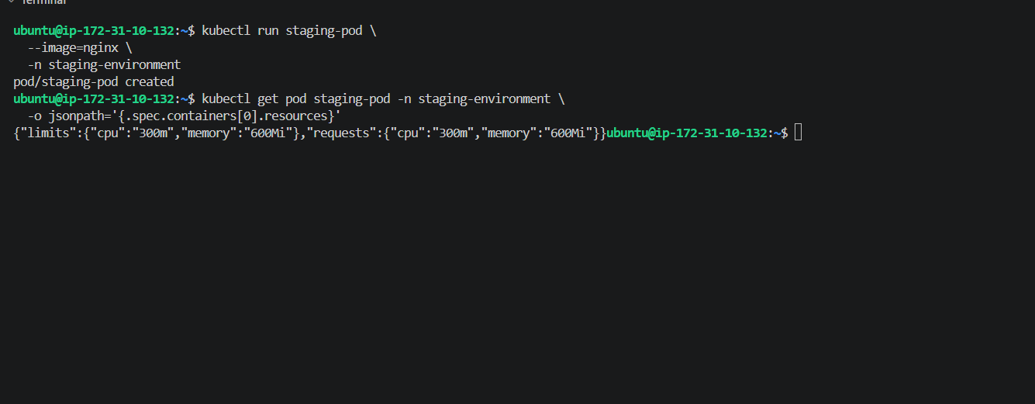
Step 4 — Pod + NodePort + Service DNS
Now we're going to demonstrate an important Kubernetes concept:
test namespace
│
│ HTTP request
↓
web-service.default.svc.cluster.local
│
↓
default namespace
│
↓
web-pod
│
↓
NGINX
4.1 Create the web Pod in default
Run:
nano web-pod.yaml
Paste:
apiVersion: v1
kind: Pod
metadata:
name: web-pod
namespace: default
labels:
app: web
spec:
containers:
- name: nginx
image: nginx:latest
ports:
- containerPort: 80
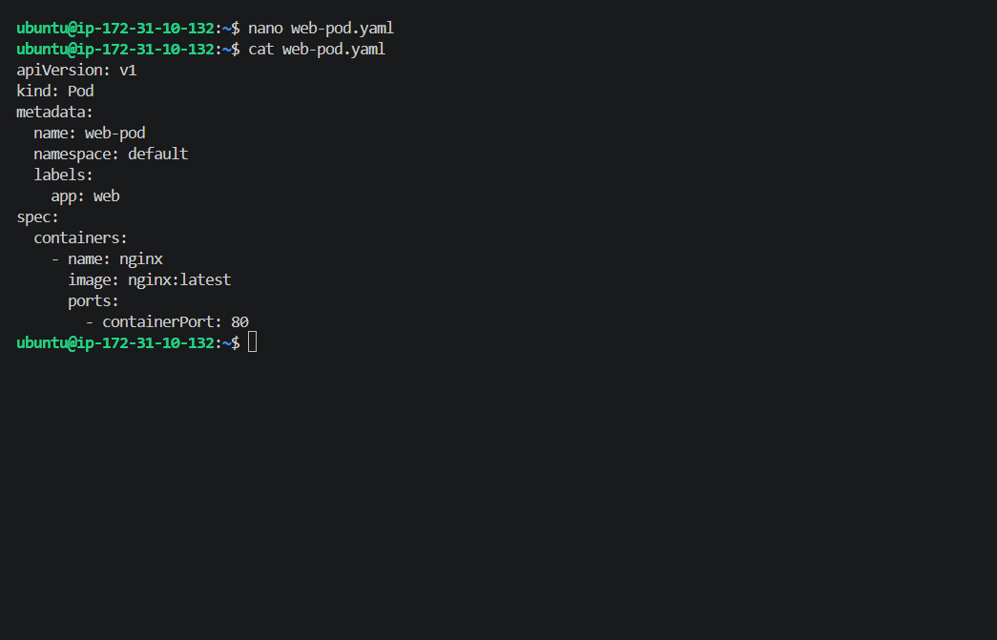
Save and apply:
kubectl apply -f web-pod.yaml
Check:
kubectl get pod web-pod
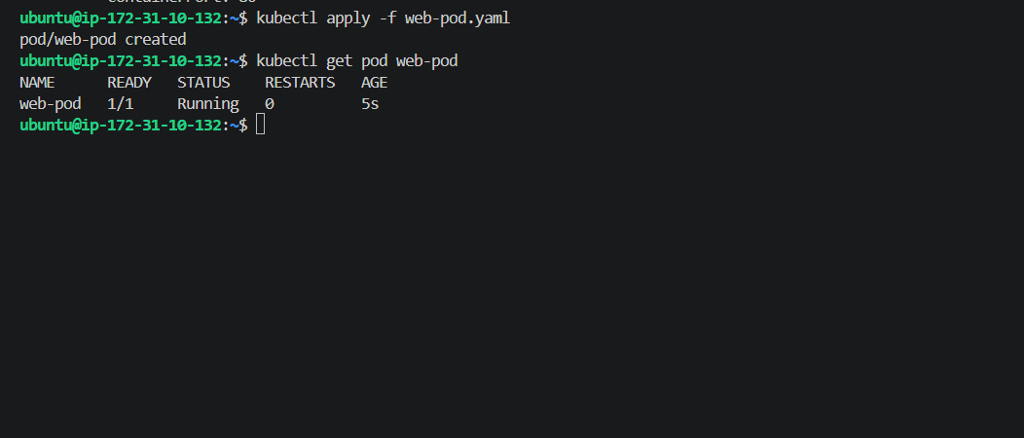
4.2 Create the NodePort Service
Create:
nano web-service.yaml
Paste:
apiVersion: v1
kind: Service
metadata:
name: web-service
namespace: default
spec:
type: NodePort
selector:
app: web
ports:
- port: 80
targetPort: 80
nodePort: 30080
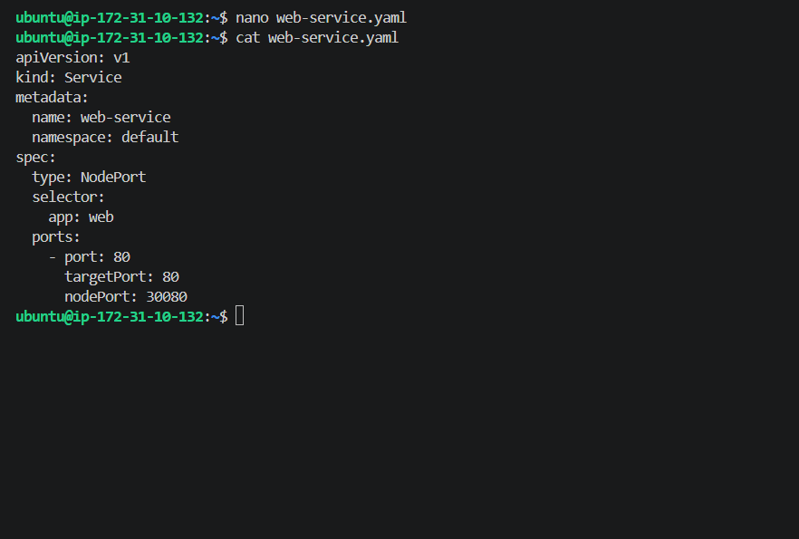
Then apply:
kubectl apply -f web-service.yaml
Expected:
service/web-service created
Verify
Run:
kubectl get svc web-service
You should see:
web-service NodePort ... 80:30081/TCP
Then check that it is connected to our Pod:
kubectl get endpoints web-service
You should see an endpoint similar to:
10.x.x.x:80
That means:
web-service
│
│ selector: app=web
↓
web-pod
│
↓
NGINX :80
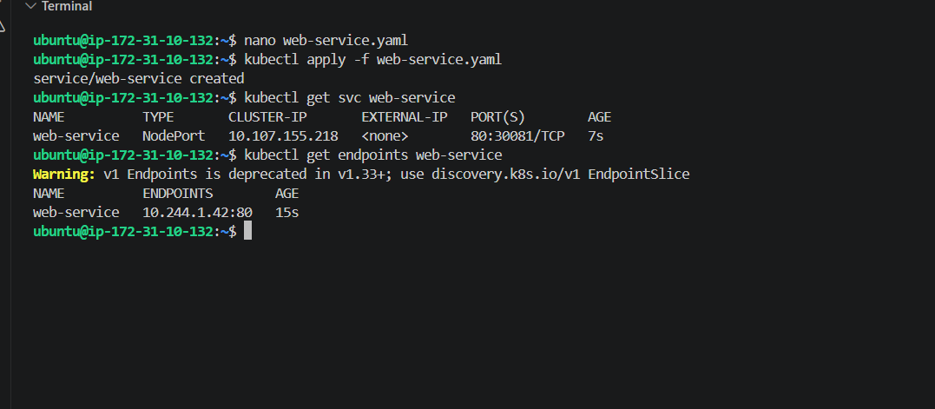
Step 4 — Create the test Pod
Now create the Pod in the test namespace.
Run:
kubectl create namespace test
Now create the test Pod:
kubectl run test-pod \
--image=busybox:1.36 \
-n test \
--command -- sleep 3600
Then check:
kubectl get pod test-pod -n test
Wait until it shows:
test-pod 1/1 Running
Then test the Service DNS
Run:
kubectl exec -it test-pod -n test -- \
wget -qO- http://web-service.default.svc.cluster.local
If everything is correct, you'll get the Nginx welcome page HTML.
This is the key proof for Task 5:
test-pod (test namespace)
↓
web-service.default.svc.cluster.local
↓
web-service (default namespace)
↓
web-pod
↓
Nginx
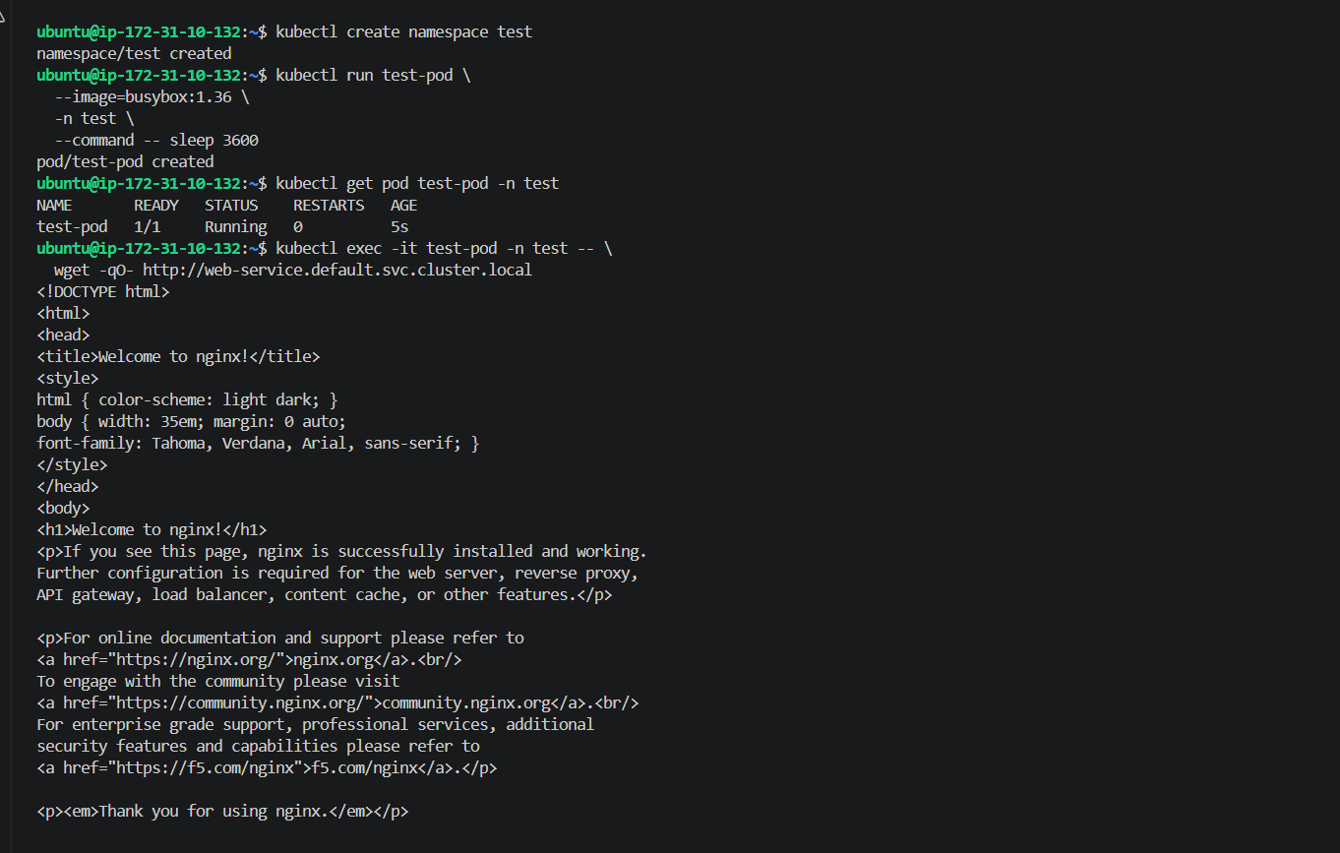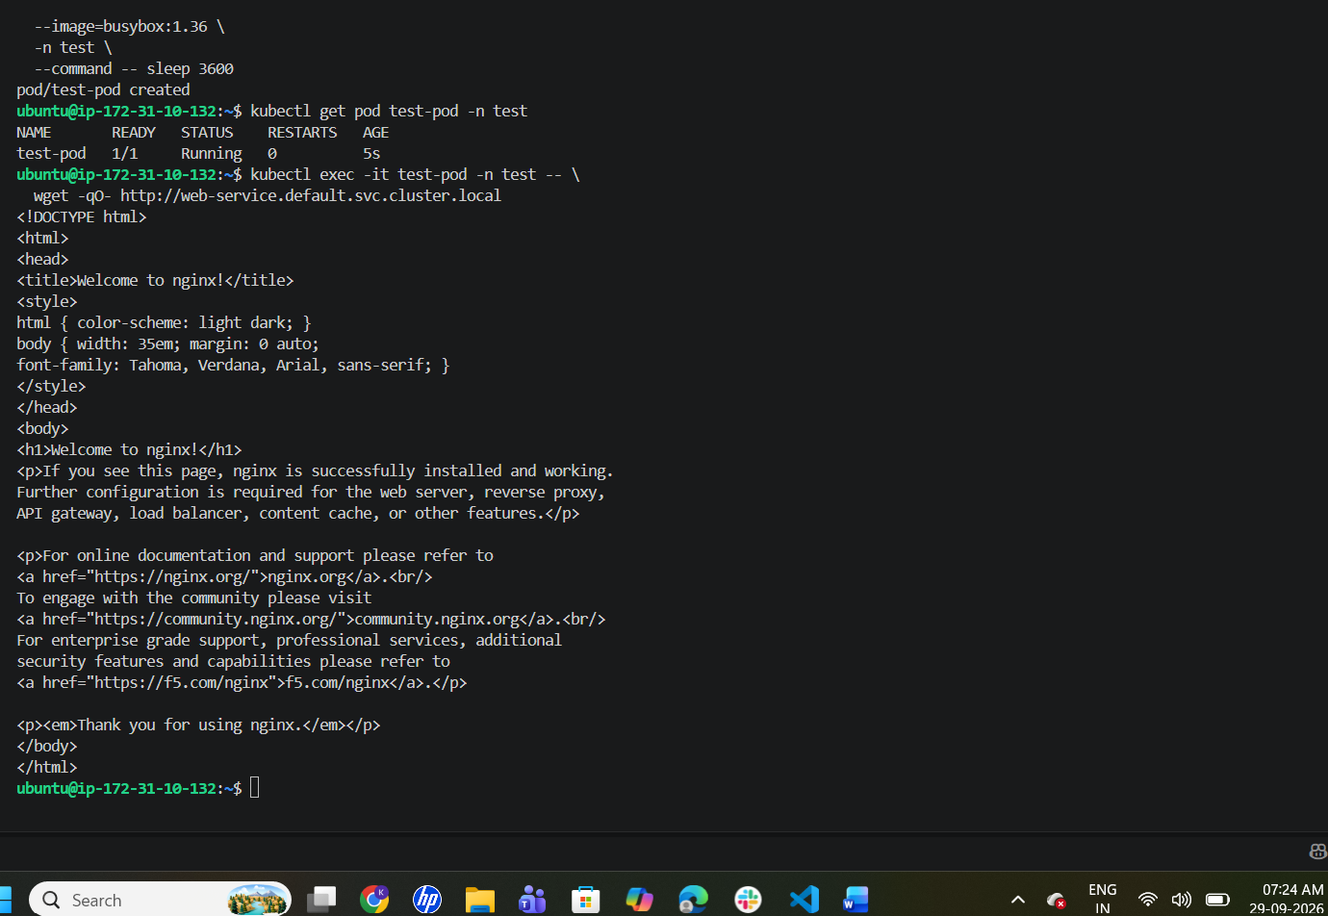
  - Step 5 — Memory Limit/Request Ratio
5.1 Create namespace
Run:
kubectl create namespace performance-environment
Expected:
namespace/performance-environment created
5.2 Create LimitRange
Run:
nano performance-limitrange.yaml
Paste:
apiVersion: v1
kind: LimitRange
metadata:
name: performance-limitrange
namespace: performance-environment
spec:
limits:
- type: Container
maxLimitRequestRatio:
memory: "2"
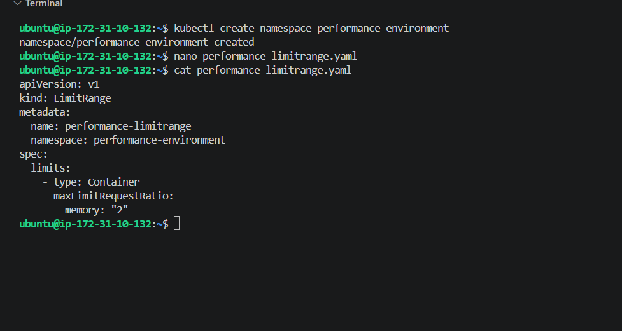
Apply:
kubectl apply -f performance-limitrange.yaml
Expected:
limitrange/performance-limitrange created
Verify:
kubectl describe limitrange performance-limitrange \
-n performance-environment
You should see:
Max Limit Request Ratio:
memory: 2
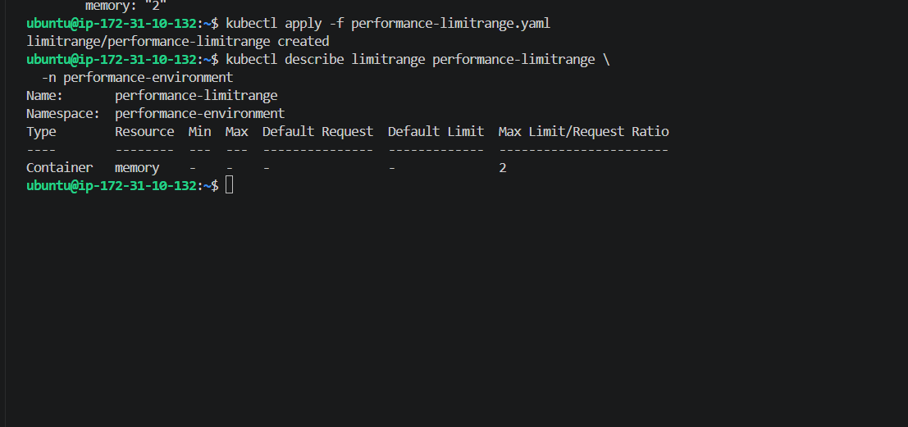
Step 5A — Create a valid Pod
We'll use:
Memory request = 200Mi
Memory limit = 400Mi

400 / 200 = 2 ✅
Create the file:
nano performance-valid.yaml
Paste:
apiVersion: v1
kind: Pod
metadata:
name: performance-valid
namespace: performance-environment
spec:
containers:
- name: nginx
image: nginx:latest
resources:
requests:
memory: "200Mi"
limits:
memory: "400Mi"
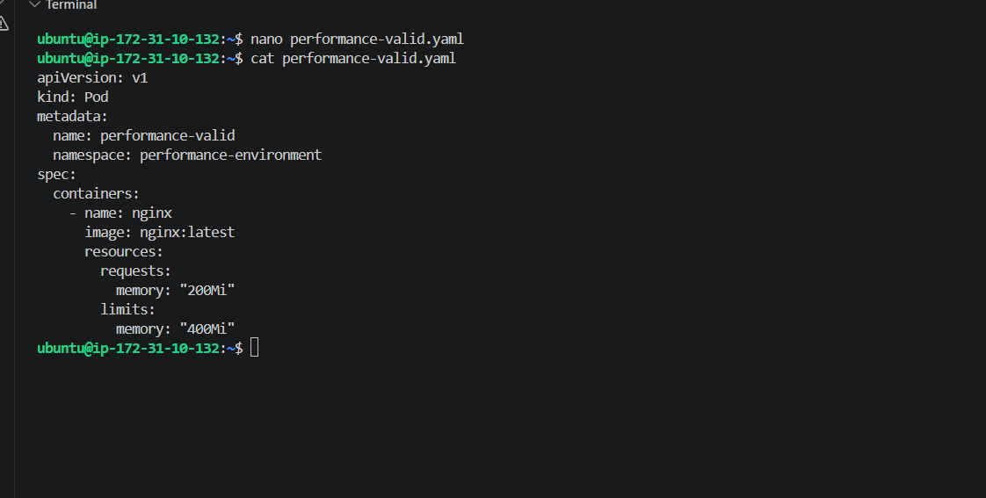
Save and apply:
kubectl apply -f performance-valid.yaml
Expected:
pod/performance-valid created
Verify:
kubectl get pod performance-valid -n performance-environment
It should eventually show:
performance-valid 1/1 Running
Then verify resources:
kubectl get pod performance-valid \
-n performance-environment \
-o jsonpath='{.spec.containers[0].resources}'
Expected:
{"limits":{"memory":"400Mi"},"requests":{"memory":"200Mi"}}
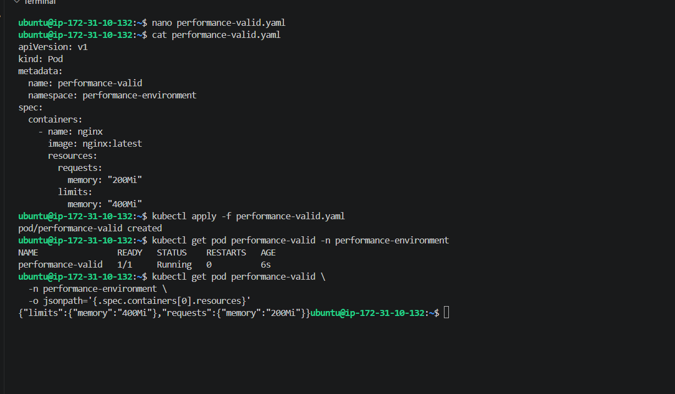
Final Test — Intentionally Invalid Pod
Now we'll prove that Kubernetes rejects a Pod whose memory limit/request ratio is greater than 2.
We'll use:
Request = 200Mi
Limit = 600Mi

600 / 200 = 3 ❌
Create:
nano performance-invalid.yaml
Paste:
apiVersion: v1
kind: Pod
metadata:
name: performance-invalid
namespace: performance-environment
spec:
containers:
- name: nginx
image: nginx:latest
resources:
requests:
memory: "200Mi"
limits:
memory: "600Mi"
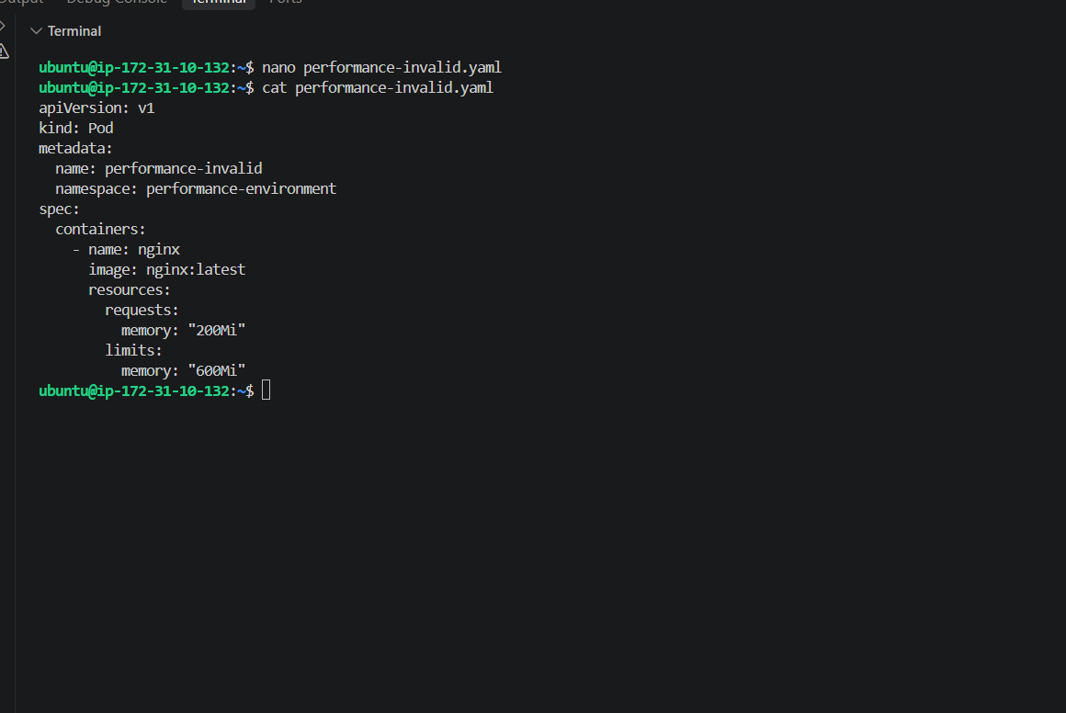
Now apply it:
kubectl apply -f performance-invalid.yaml
Expected result
This time, we want it to fail.
You should get an error similar to:
Error from server (Forbidden):
pods "performance-invalid" is forbidden:
[maximum memory usage per Container is 2,
but limit/request ratio is 3]
The exact wording can vary with Kubernetes version.
Then verify that it was not created:
kubectl get pod -n performance-environment
You should see only:
performance-valid
and not:
performance-invalid
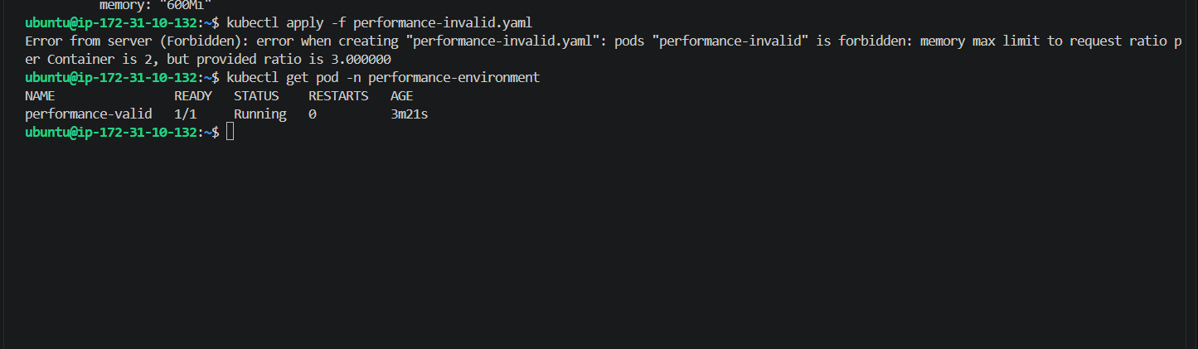
Your final test produced exactly the expected result:
memory max limit to request ratio per Container is 2,
but provided ratio is 3.000000
And Kubernetes rejected the invalid Pod. ✅
Your namespace contains only the valid Pod:
performance-valid 1/1 Running

